Packing List
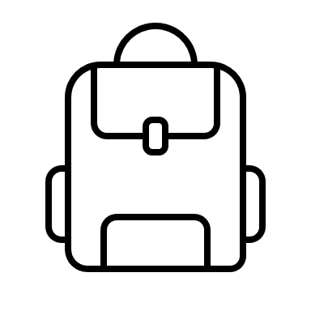 | 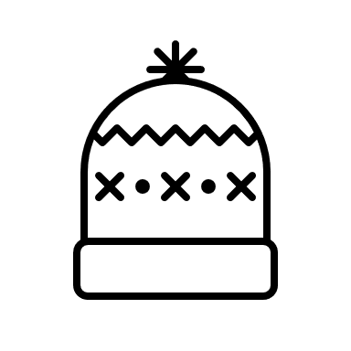 | 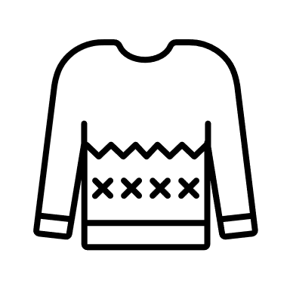 | 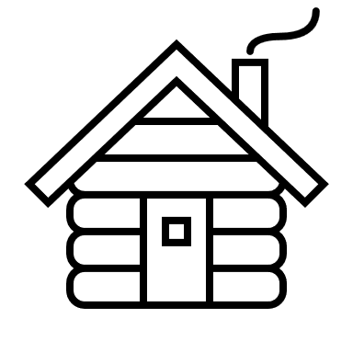 | 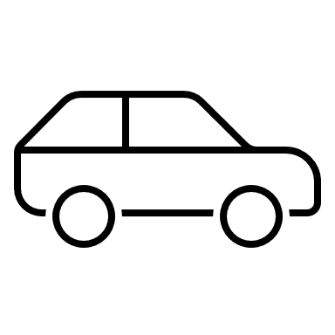
Comes with you each day on tours | Have readily accessible | Wear or have available skiing | For using at the chalet | To leave in the car on the night before

Code | Item | Qty | Optional? |  | Code | Item | Qty | Optional?
 | Sleeping mat | 1 | No |  |  | Hike towel | 1 | No
 | Breakfast for Saturday | 1 | No |  |  | Phone charger and cord | 1 | Yes
 | Lunch for Saturday | 1 | No |  |  | Ear plugs | 1 | Yes
 | Bag | 1 | Yes |  |  | Eye mask | 1 | Yes
 | Spare clothes | 1 | Yes |  |  | Rapid antigen tests | 5 | No
 | Extra sleeping bag | 1 | Yes |  |  | Facemask | 1 | No
 | Pillow | 1 | Yes |  |  | Party night costume | 1 | Yes
 | Pack | 1 | No |  |  | Over 18’s only | 1.5kg | Yes
 | Skis | 1 | No |  |  | Sleeping bag | 1 | No
 | Stocks/poles | 1 | No |  |  | Inner sheet | 1 | Yes
 | Ski boots | 1 | No |  |  | Single fitted mattress sheet | 1 | No
 | Ski leashes | 1 | Yes |  |  | Pillow case | 1 | No
 | Water bottle | 2 | No |  |  | Pyjamas | 1 | Yes
 | Whistle | 1 | No |  |  | Indoor t-shirt | 1 | Yes
 | Map | 1 | Yes |  |  | Indoor pants | 1 | Yes
 | Compass | 1 | No |  |  | Closed toe shoes | 1 | No
 | UHF Radio | 1 | Yes |  |  | Scout uniform | 1 | No
 | PLB | 1 | Yes |  |  | Toiletries bag | 1 | Yes
 | Space blanket | 1 | No |  |  | Travel soap | 1 | No
 | Personal first aid kit | 1 | No |  |  | Shampoo/conditioner | 50mL | Yes
 | Scroggin | 500g | No |  |  | Toothbrush and paste | 1 | No
 | Head torch | 1 | No |  |  | Clear sunglasses | 1 | Yes
 | Lighter/matches | 1 | Yes |  |  | Deodorant | 1 | No
 | Daypack | 1 | Yes |  |  | Shower cap | 1 | Yes
 | Gaiters | 1 | Yes |  |  | Periods items | 7 | No
 | Whiteout cord | 1 | No |  |  | Socks | 3 | No
 | Ski helmet | 1 | Yes |  |  | Moisturiser | 30mL | Yes
 | Medication | personal | No |  |  | Hair ties | 3 | Yes
 | Glide wax | 1 | Yes |  |  | Underwear | 3 | No
 | Ski repair kit | group | Yes |  |  | Bra | 2 | Yes
 | Sunscreen | 1 tube | No |  |  | Thermal top | 2 | No
 | Pocket knife/multitool | 1 | Yes |  |  | Thermal pants | 2 | No
 | Chemical warmers | 1 | Yes |  |  | Board shorts | 2 | Yes
 | Toilet paper | 0.5 | Yes |  |  | Mid layer | 1-2 | No
 | Lip balm | 1 | No |  |  | Hat | 1 | No
 | Sit pad | 1 | No |  |  | Lightweight finger gloves/mitts | 1 | No
 | Ski straps | 1 | Yes |  |  | Sunglasses | 1 | No
 | Ski goggles | 1 | Yes
 | Fleece/puffer | 1 | No
 | Raincoat | 1 | No
 | Rain pants | 1 | No
 | Beanie | 1 | No
 | Buff/scarf | 1 | Yes
 | Warm gloves/mitts | 1 | No
 | Glove liners | 1 | Yes

